Fabrication lab

Experiment: 1

Cleaning of Silicon Wafer

19EC10088

Sounak Mandal

Aim

The aims of the experiment are:

1. To understand the types and specifications for Silicon wafers.
2. To understand the various cleaning procedures to make the Silicon wafer suitable for further steps of fabrication.

Introduction

Wafers are thin slices of semiconductor material on which microfabrication is done. It serves as a substrate over which microelectronic devices are manufactured. Silicon wafers are polished and fabrication is done only on the polished side. However, before fabrication, they must be cleaned stepwise which is what is outlined in this experiment.

Apparatus Used

1. Quartz Beaker
2. Wafer holder
3. Teflon tweezer
4. Nitrile Gloves
5. Borosil Glass beakers
6. Nitrogen gun
7. Desiccator

Chemicals Used

1. 98% sulphuric acid (H2SO4)
2. 30% hydrogen peroxide (H2O2)
3. 1% buffer hydrofluoric acid (HF) solution
4. Nitrogen gas (N2)
5. Deionised (DI) water (18.2 MΩ cm)

Types of Silicon Wafers

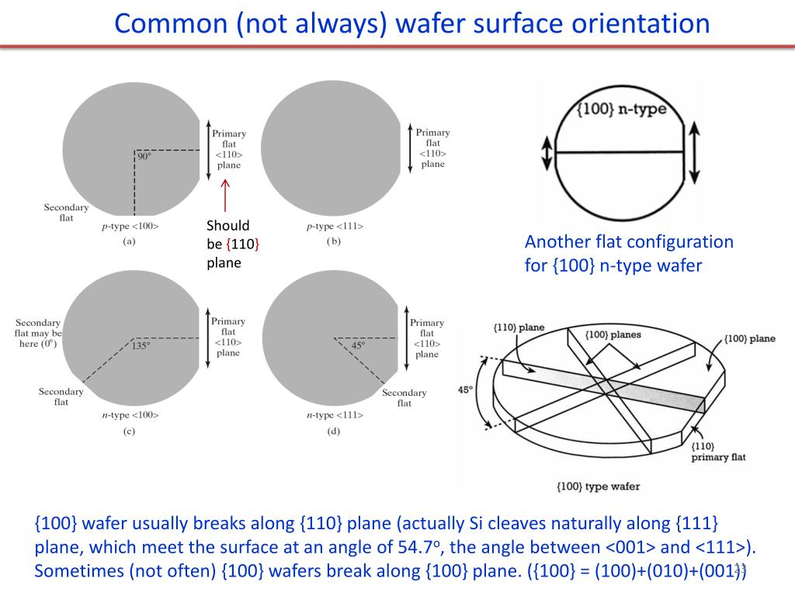

A semiconductor can be doped by different types of impurities that result in different types of carriers carrying current in it. N-type semiconductor primarily has electrons as carriers while for p-type it is holes.

Since silicon wafers are produced from pure blocks of silicon crystals, the orientation of the crystal planes also comes into picture. Different crystal planes are different since the number of silicon and impurity atoms would be different on them.

It's not always possible during fabrication that the operator would manually check every wafer for the impurity type and the crystal plane orientation. Hence a uniform procedure of marking the wafer is established that easily helps us to distinguish them at a glance.

1. P doped {111} wafer has primary flat.
2. N doped {111} wafer has primary and secondary flat at an angle of 45°.
3. P doped {100} wafer has primary and secondary flat at an angle of 90°
4. N doped {100} wafer has primary and secondary flat at an angle of 135° or in some cases 180°.

Czochralski Process

It is a method of converting polycrystalline silicon obtained from silicon extraction from chemical processes to monocrystal of silicon. Impurities can also be incorporated into the crystal quite uniformly using this method.

First polycrystalline silicon is melted in a quartz crucible. The furnace is heated to a very high temperature above the melting point of silicon (about 1500° C) so that it converts to a melt. To this melt, calculated amounts of dopant are added based on the final doping concentration.

To initiate crystallization, a seed crystal tied to one end of a rotating shaft is slowly lowered into the crucible so that it reaches just below the surface of the melt. The seed crystal is then slowly pulled out of the crucible during which the molten silicon crystallizes around preserving the same orientation. During pulling out the crystal generally, the shaft and crucible are rotated in opposite directions to ensure uniform distribution of the dopant atoms and to make the temperature uniform throughout the melt.

The single crystal ingot obtained after the process is further sliced into the thin wafers and polished to make it fit for further process of fabrication.

Types of Cleaning Process

Before fabrication can be started on the wafer, it must be cleaned thoroughly to ensure that the surface does not contain any sort of impurity which may ultimately degrade the performance of the device fabricated. Needless to mention, we only wish the surface to be affected by the cleaning process since the bulk is already crystalline with the required amount of impurity.

The various cleaning procedure employed are:

1. **RCA base cleaning**: It is used to remove organic and metal ion contaminants from the surface. It consists of two sequential steps:
2. **Standard Clean (SC) -1**: This uses an Alkaline peroxide mixture (APM) and removes organics and heavy metals.
3. **Standard Clean (SC) – 2**: This uses a Hydrochloric peroxide mixture (HPM) which removes alkaline ions and metals.
4. **Piranha acid cleaning:** This is an alternative method to remove organic and metal ions from the surface.
5. **Acetone cleaning:** This is used to remove the inorganic contaminants from the surface. Generally, organic matter removal involves chemicals and this method is used to remove those chemicals.

Piranha cleaning process

This involves the following steps successively:

1. The wafer is transferred from the wafer holder to the quartz beaker with the help of Teflon tweezers.
2. H2O2 is poured into the beaker followed by an equal volume of H2SO4.
3. The solution is kept in the beaker for about 45 minutes till effervescence subsides.
4. The wafer is washed in DI water. At this stage the surface is hydrophobic due to the presence of native oxide which is removed in subsequent steps.
5. The wafer is dipped in buffered HF solution to etch out the native oxide layer. Any impurity in the oxide layer itself gets washed away later during rinsing.
6. The wafer is again washed with DI water which washes away the impurities in oxide layers. At this stage the surface should be hydrophilic since the oxide layer has been removed.
7. The wafer is blow-dried with the help of a nitrogen gun and kept isolated in a desiccator.

The main chemical reaction involved with the Piranha cleaning process is:

$$H_{2}SO_{4}+H_{2}O_{2}{ →H}_{2}SO_{5}+H_{2}O$$

Precautions

1. Teflon tweezers are used to prevent any contamination during transfer. In general, nothing is touched with bare hands.
2. Peroxide should be added first and then sulphuric acid should be added. This is because the reaction is highly exothermic which is absorbed by the peroxide. Should the sulphuric acid be added first it won’t be able to absorb the heat which would cause splashing of the dangerous chemical.
3. The exothermic reaction also should be carried out in a quartz beaker since normal glass beaker may break due to the extremely high temperature of about 80°C - 100°C.
4. Quartz apparatus should be used since Caro's acid (H2SO5) produced upon reaction is highly corrosive and may melt through the glass apparatus.
5. PPE kits should be used and chemicals must be disposed suitably since the procedure involves highly corrosive chemicals and noxious fumes.

Conclusions

1. The presence of native oxide on the surface can be ascertained by visual inspection. It gives a pinkish tint if the oxide layer is not completely etched but a very shiny and silvery, hydrophilic appearance if the oxide layer is successfully removed.
2. The ratio of peroxide to acid is not fixed. It can vary anywhere from 1:1 for laboratory to as skewed as 1:4 for industries.